Graph Coloring and Exam Timetable Scheduling:
1. Introduction
Graph Coloring and Exam Timetable Scheduling is a mini-project that helps a college prepare an examination timetable without scheduling two conflicting exams at the same time.
In a college, many students study multiple subjects. If the same students have to write two different exams, those exams must be conducted at different times.
Preparing a timetable manually can be difficult when there are many subjects and student groups. This project uses Graph Coloring and Backtracking to assign examination time slots automatically.
Example
Suppose a college has four subjects:
- ADSAA
- DBMS
- Computer Networks (CN)
- Python Programming
Some students study both ADSAA and DBMS. Therefore, these two exams cannot be held at the same time.
The program identifies these conflicts and assigns suitable time slots.
2. Objectives of the project
- To generate an examination timetable automatically.
- To identify subjects that cannot be scheduled at the same time.
- To apply the Graph Coloring technique to timetable scheduling.
- To use Backtracking to find a valid assignment of time slots.
- To reduce timetable preparation time and avoid exam clashes.
- To demonstrate a practical application of graph algorithms.
3. Basic concepts
A. What is a graph?
A graph is a collection of vertices (nodes) and edges (connections).
In this project:
- Each vertex represents one subject.
- An edge between two subjects indicates that they have common students.
- Connected subjects must be assigned different time slots.
For example, if ADSAA and DBMS have common students, we connect their vertices with an edge.
B. What is graph coloring?
Graph Coloring is a technique in which different colors are assigned to connected vertices so that no two connected vertices have the same color.
In our project, each color represents an examination time slot.
Graph coloring example
Suppose ADSAA conflicts with DBMS, and DBMS conflicts with CN.
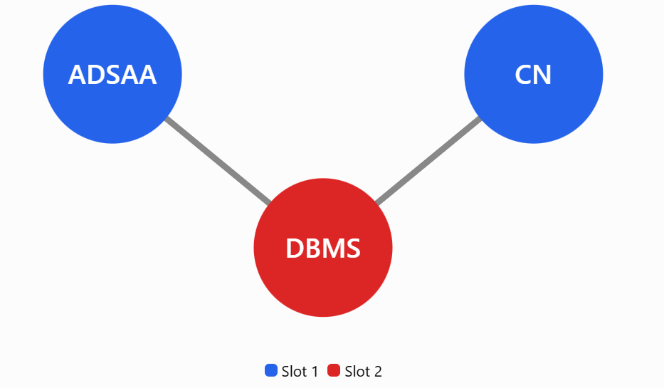
ADSAA and CN can share Slot 1 because there is no edge between them. DBMS uses Slot 2 because it conflicts with both.
C. What is backtracking?
Backtracking is an algorithmic technique that builds a solution step by step.
If the current assignment causes a conflict, the algorithm removes that assignment and tries another time slot.
Simple example:
- Assign Slot 1 to ADSAA.
- Try Slot 1 for DBMS.
- If ADSAA and DBMS conflict, reject Slot 1 for DBMS.
- Try Slot 2 for DBMS.
- Continue assigning slots to the remaining subjects.
- If no slot works, go back and change an earlier assignment.
This process continues until a valid timetable is found or all possibilities have been tried.
4. Explanation of the code:
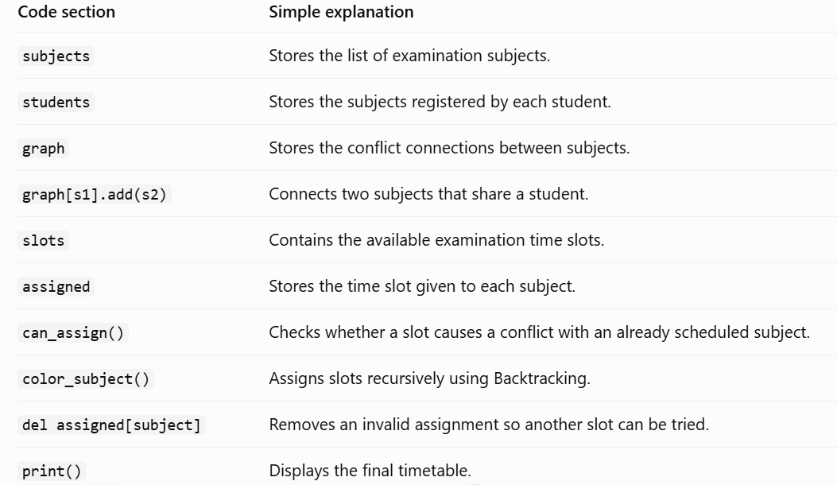

5. Sample output:
When you run the program, the output will be:
EXAMINATION TIMETABLE
---------------------
ADSAA : Day 1 - Morning
DBMS : Day 1 - Afternoon
CN : Day 2 - Morning
Python : Day 1 - Morning
Mathematics : Day 1 – Afternoon

6. Algorithm: Graph Coloring using Backtracking
- Start.
- Read the subjects and student registrations.
- Create a graph in which each subject is a vertex.
- Connect two vertices if the corresponding subjects have common students.
- Select the next subject.
- Assign an available time slot if no connected subject has the same slot.
- If a valid slot is found, recursively schedule the next subject.
- If no slot is valid, remove the previous assignment and try another slot.
- If all subjects are assigned, display the timetable.
- Stop.
7. Time complexity
Let V be the number of subjects and K the number of available time slots.
- Worst-case time complexity: O(K^{V}), because the algorithm may try many possible slot assignments.
- Space complexity: O(V+E) for storing the graph, where E is the number of conflict connections, along with the assignments and recursion stack.
The algorithm works well for small and medium-sized demonstration problems, although difficult cases can require considerable computation.
8. Advantages
- Automatically generates a valid examination timetable.
- Prevents examination clashes for students who share subjects.
- Demonstrates Graph Coloring and Backtracking practically.
- Can accommodate changes in subject registrations.
- Helps colleges reduce manual timetable preparation.
- Can be extended to include classrooms, faculty availability, and examination durations.
9. Real-time applications
- College examination timetable generation.
- University examination scheduling.
- University classroom and laboratory scheduling.
- Employee shift scheduling with conflict constraints.
- Meeting scheduling for people with overlapping commitments.
10. Project submission structure
For a B.Tech ADSAA mini-project, you can prepare the report using these chapters:
- Abstract
- Introduction
- Problem Statement
- Objectives
- Existing System and Proposed System
- System Design and Graph Representation
- Algorithm and Flowchart
- Python Implementation
- Sample Input and Output
- Testing and Results
- Advantages and Limitations
- Conclusion and Future Scope
- References

